**Interação Pessoa-Máquina**

**2023/2024**

**The Modern Movie Database**

Stage 3: 1st Prototype

**Authors:**

**Lab class Nº 3**

Guilherme Campos, 60353

João Santos, 61045 **Group Nº 17**

Miguel Valido, 60477

Pedro Fernandes, 60694 **Professor:**

Teresa Romão

Month 10, 2023

# Sketches

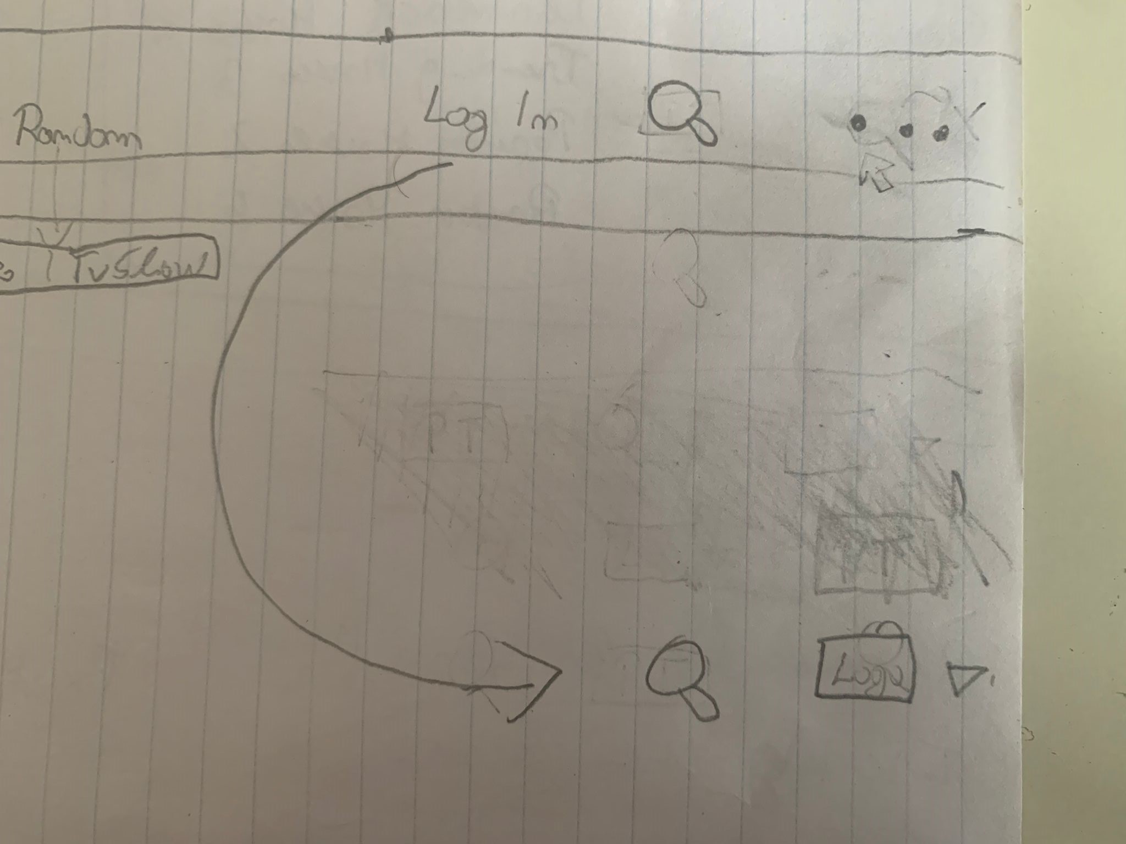

* Sketch of the transition from before to afterlog in

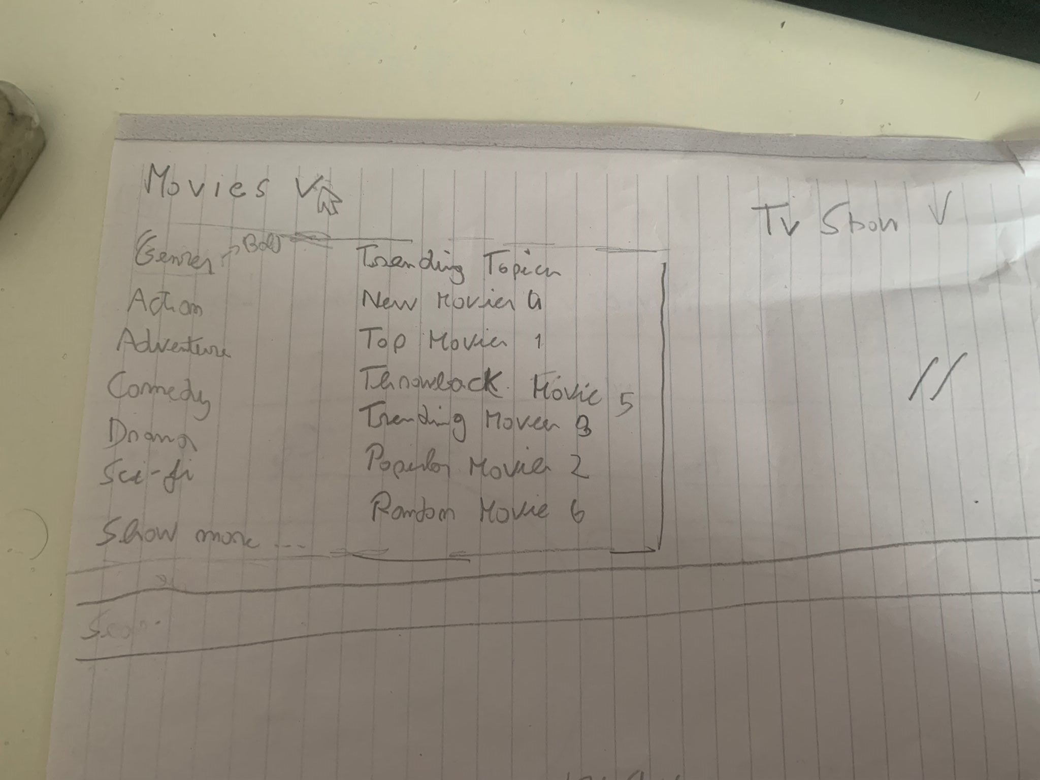

* Sketch of the dropdown table of topics and movie categories

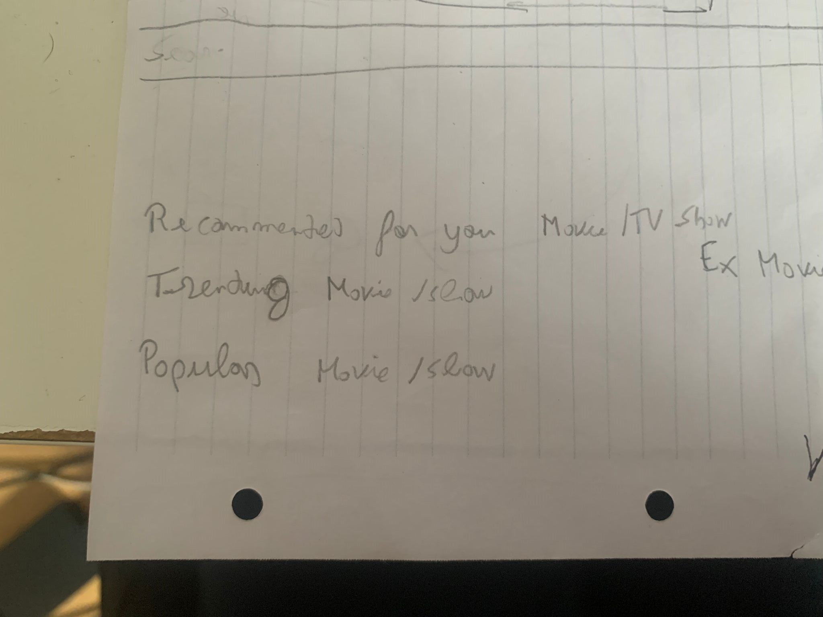

* Sketch of the numerous movie/tv show lists

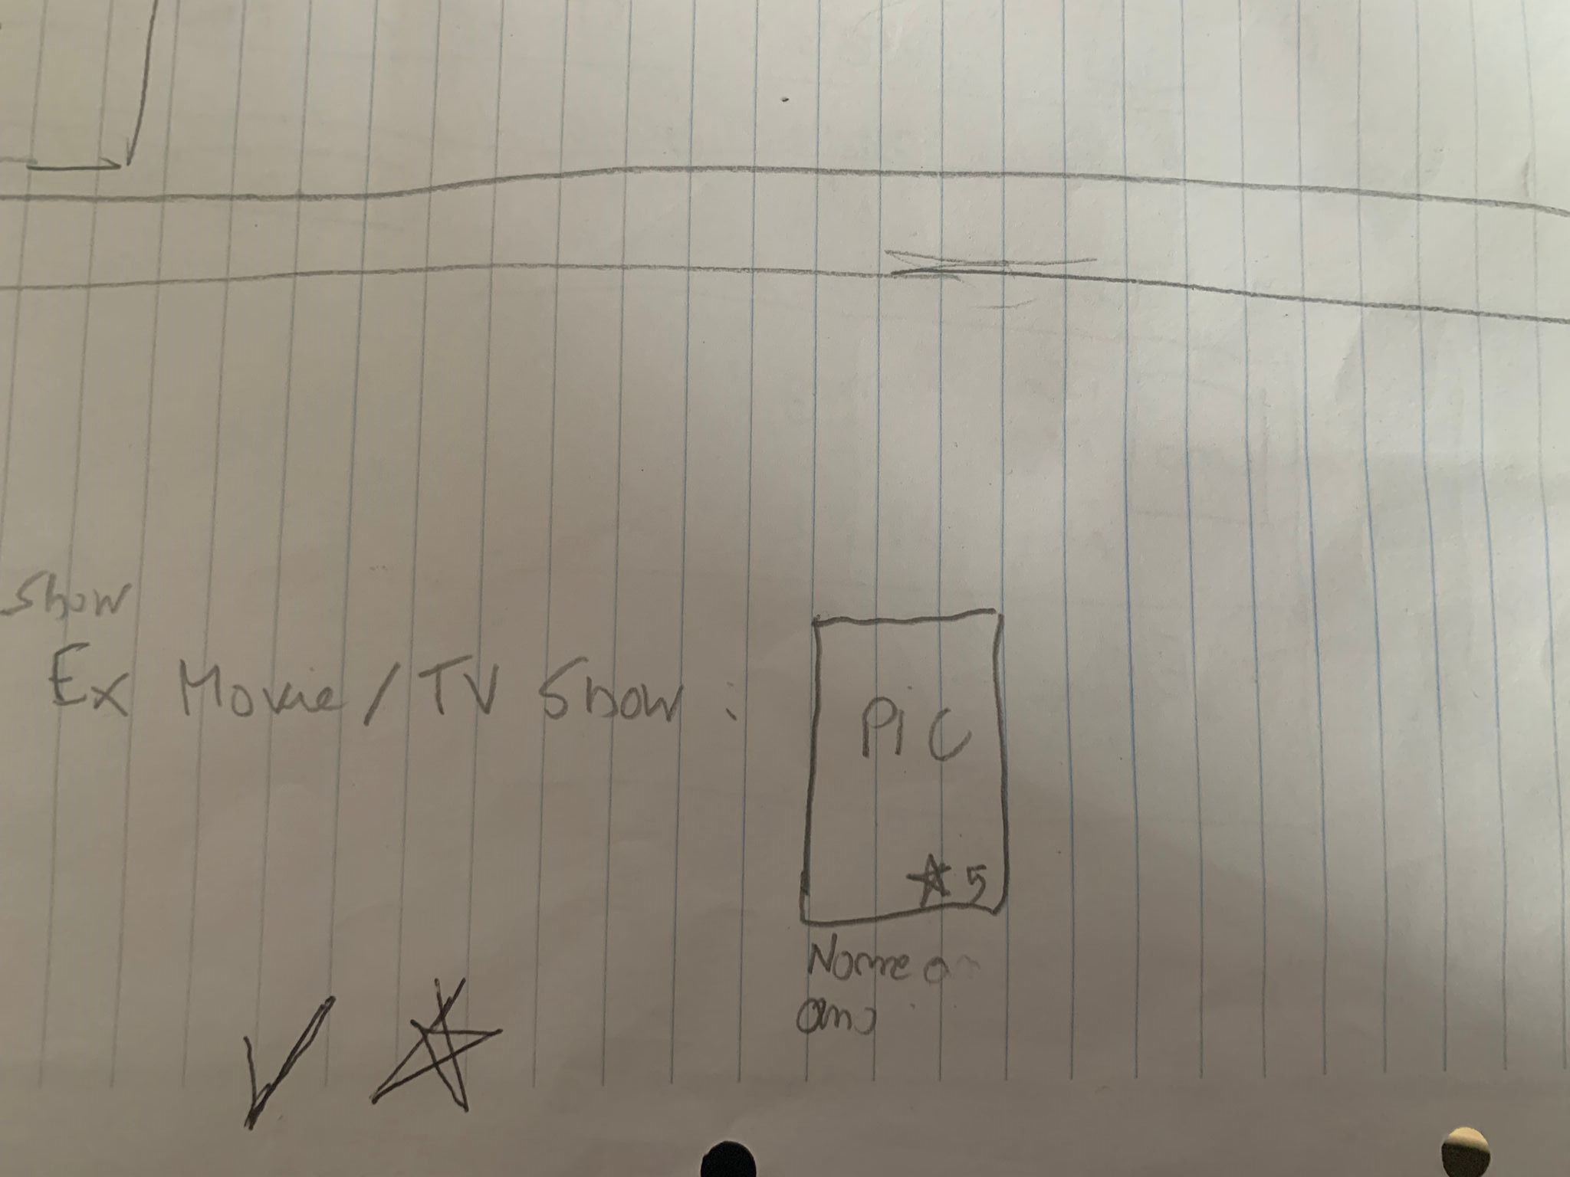

* Sketch of the movie/tv show representation

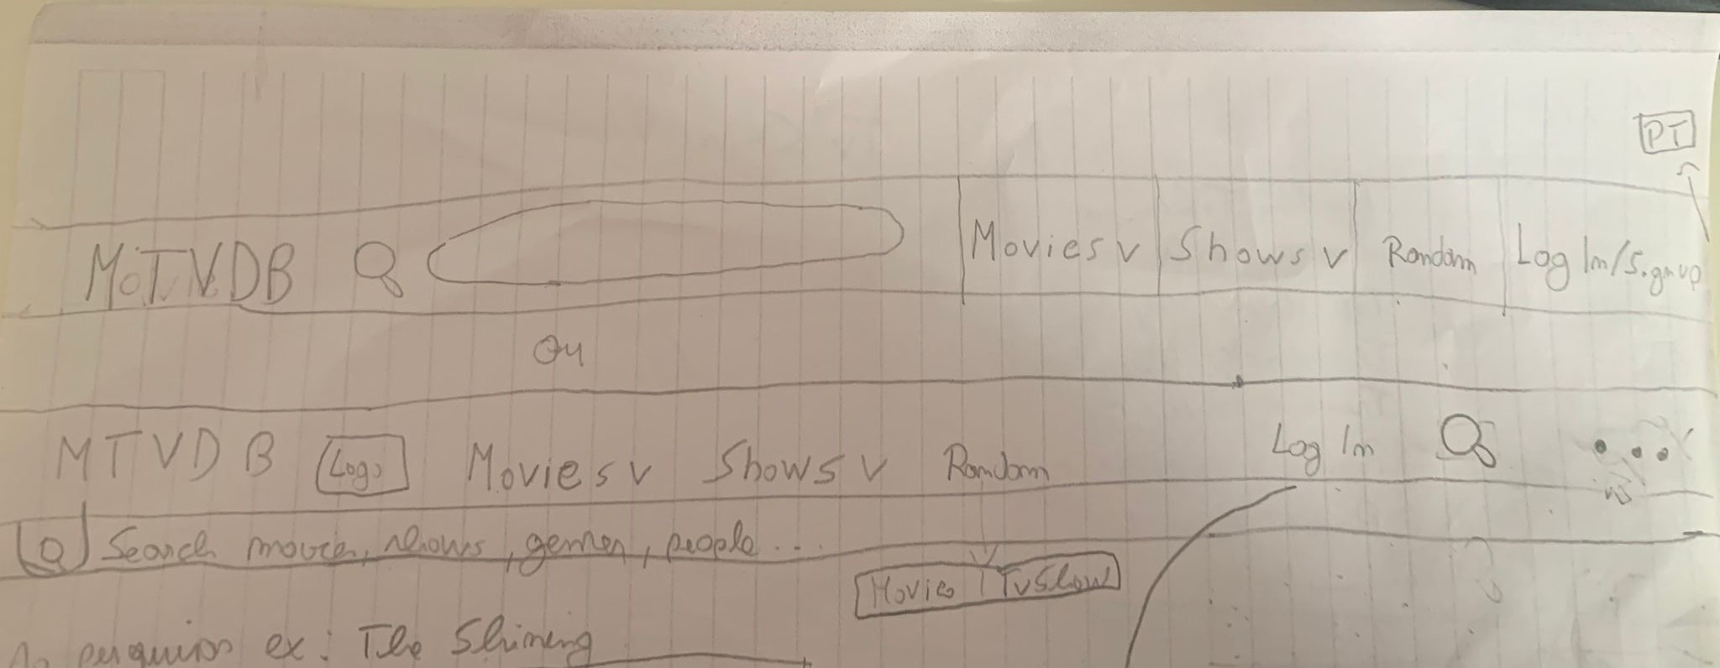

* 2 sketches of possible navigation bars

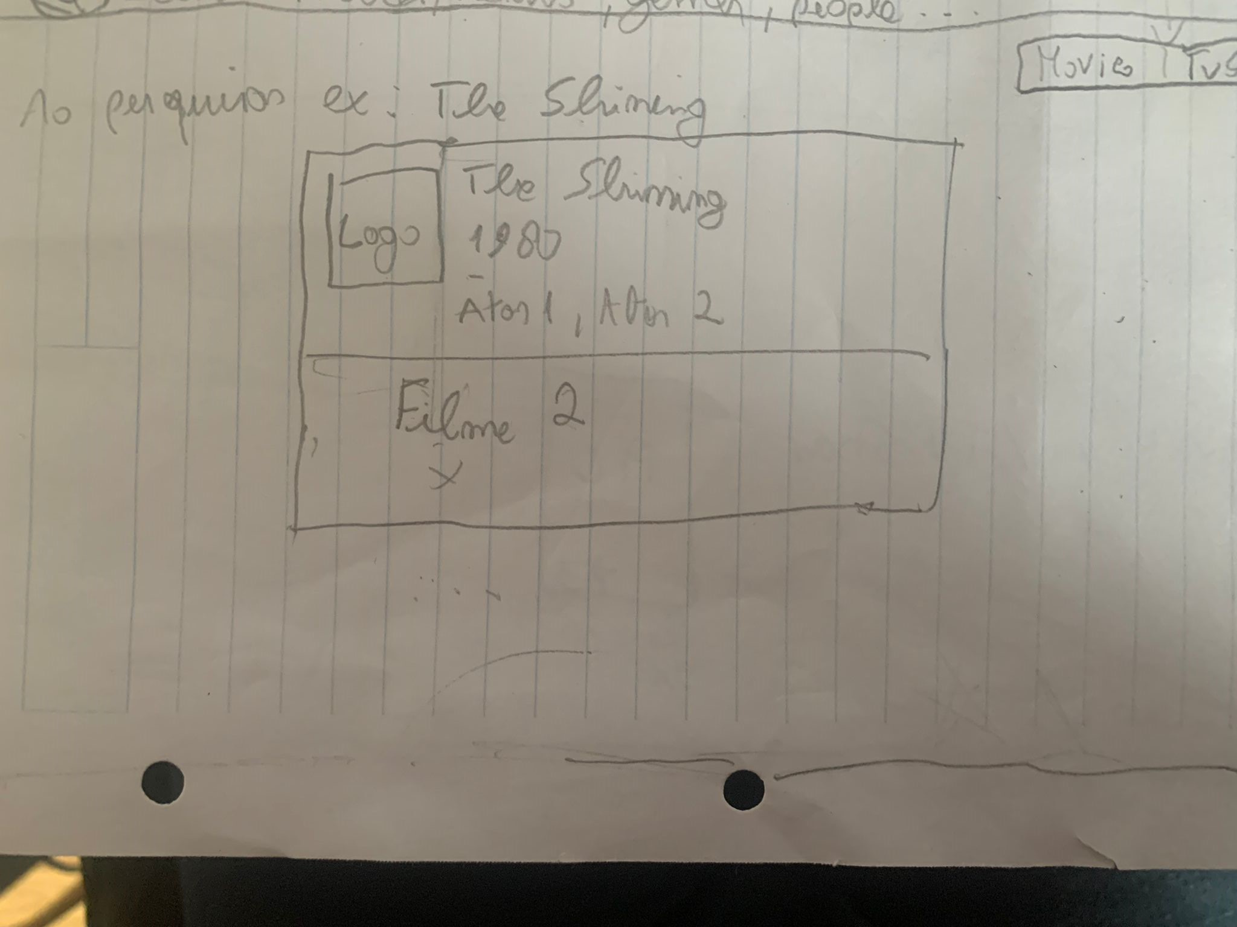

* Sketch of a dropdown which is a result of a search

# 

* Initial sketch of the home page

# Prototype Photos

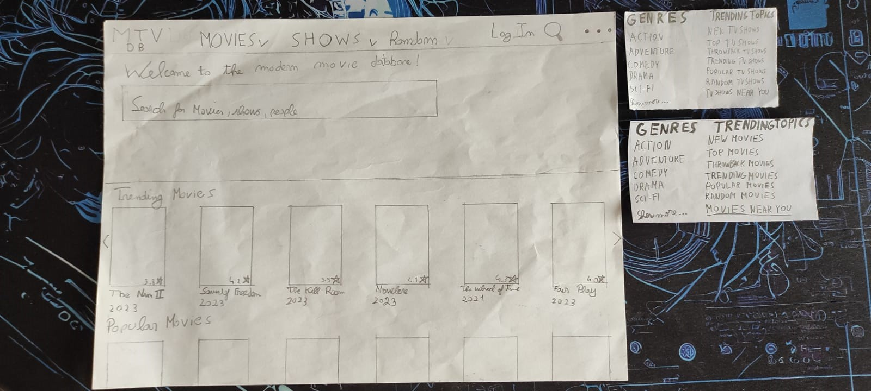

* Main page and dropdowns for Movies and Shows

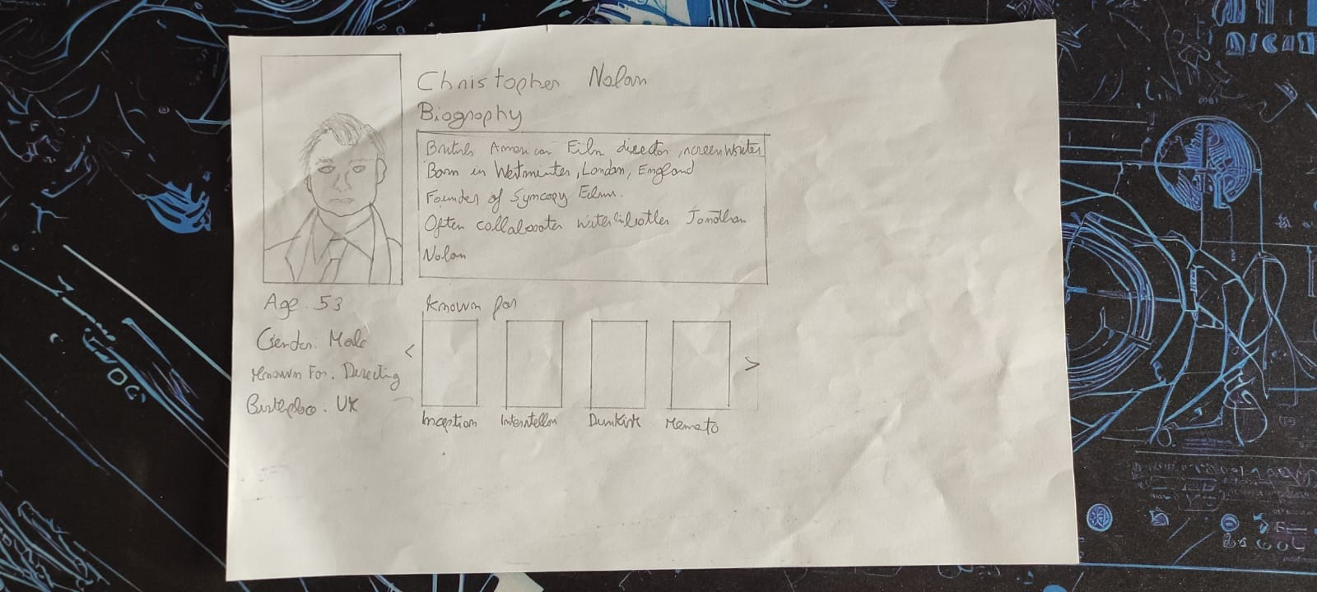

* Profile page of writer Cristopher Nolan

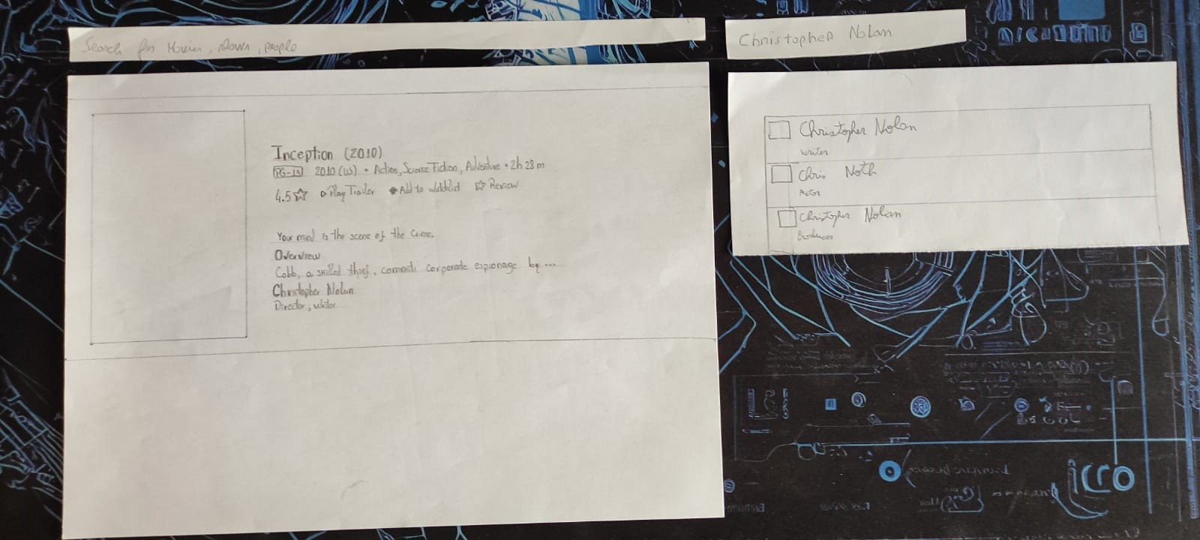

* Page for the Movie Inception, search bar, Cristopher Nolan name and dropdown of the search for him

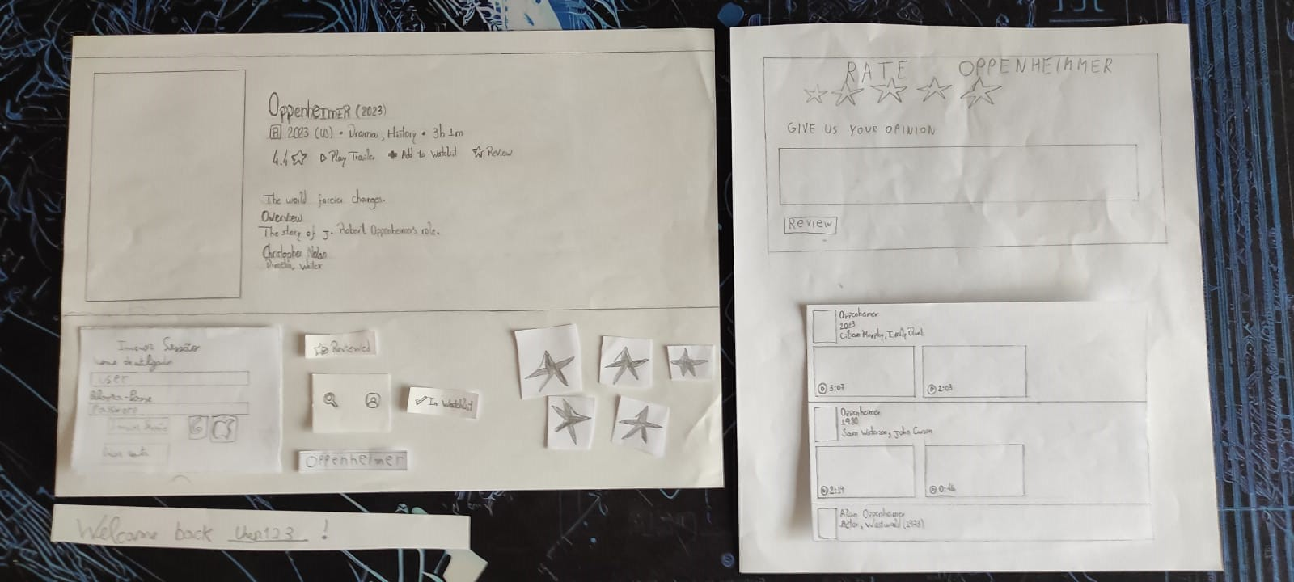

* Page for the Movie Oppenheimer, Log in screen, smalls components for reviewing purposes and interface changes, Review page and result of the search for Oppenheimer

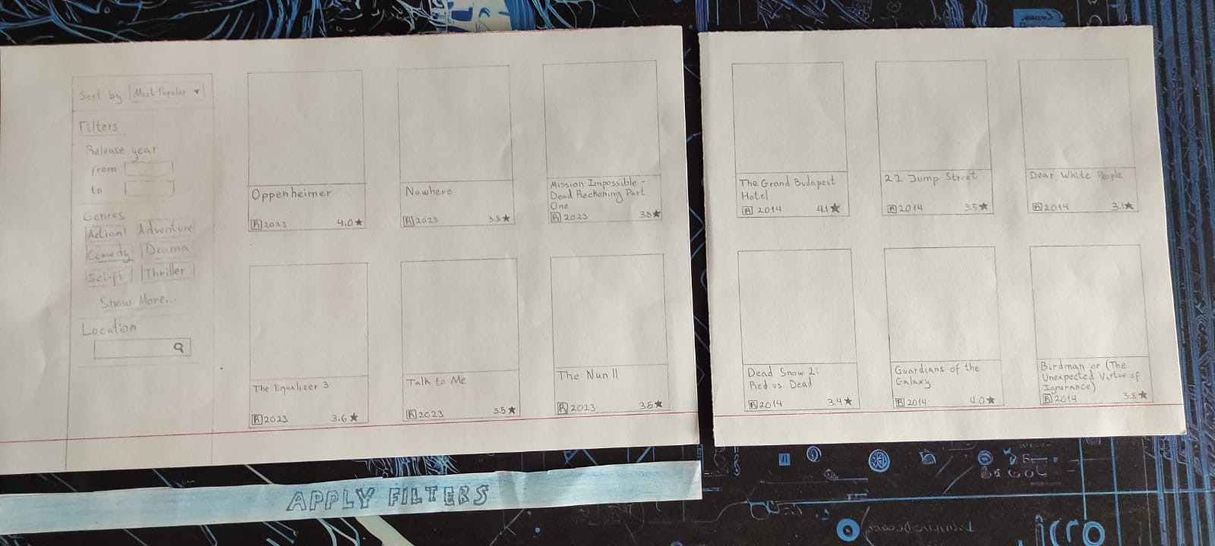

* Photo of the search page, some search results and the apply filters button

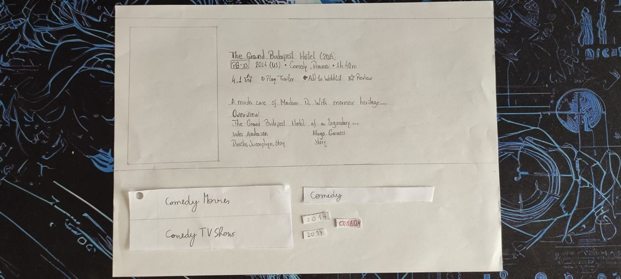

* Photo of the comedy search result, some components for searching purposes and the page of the most popular comedy movie of 2014

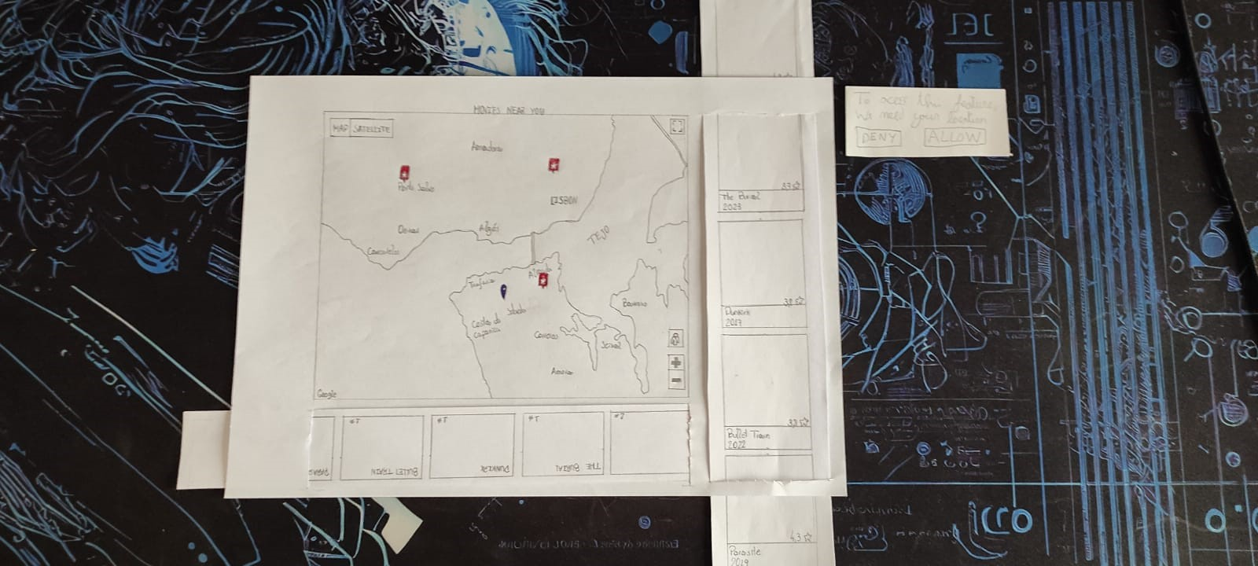

* Photo of the site’s unique feature, movies near you

# Storyboards

## Scenario 1

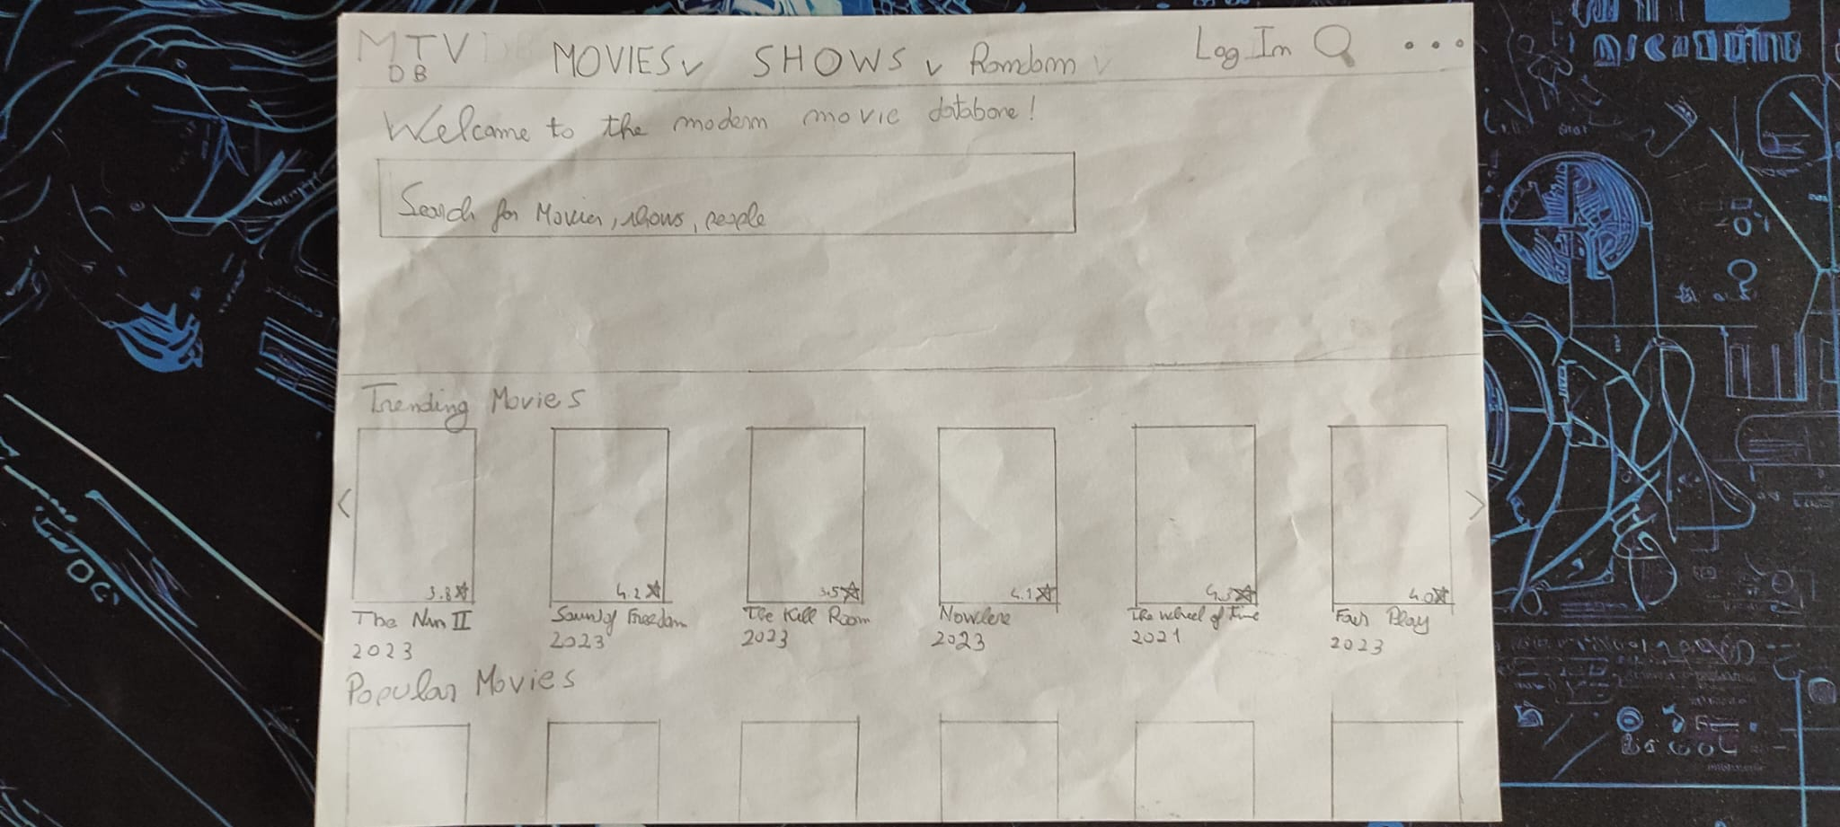

* The user wants to search for a Christopher Nolan movie.

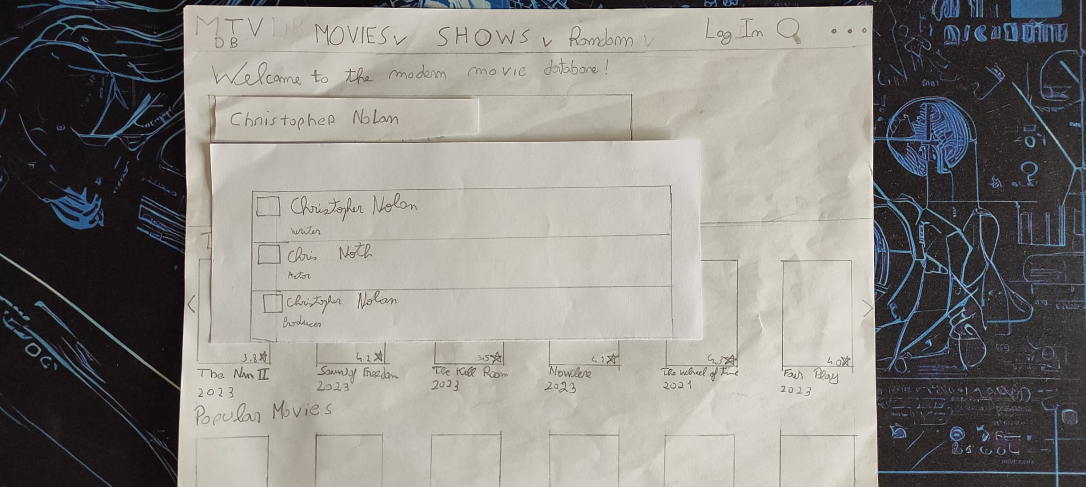

* The user types in the search the name and gets options of what

he might be searching for.

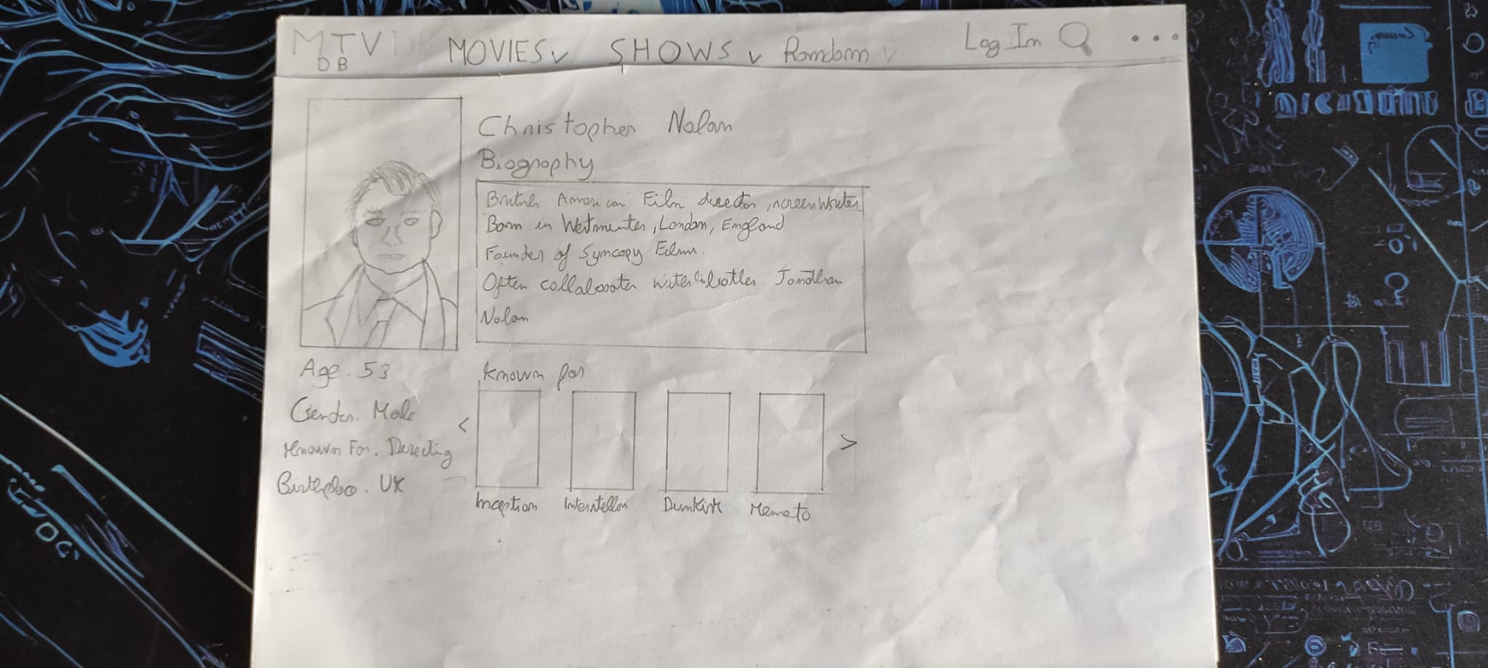

* The user finds Christopher Nolan’s page.

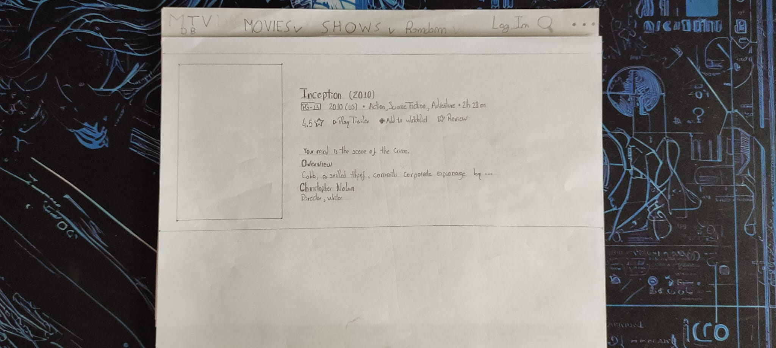

* The user ends at the movie page he was searching for.

## Scenario 2



* The user wants to search for the movie Oppenheimer.

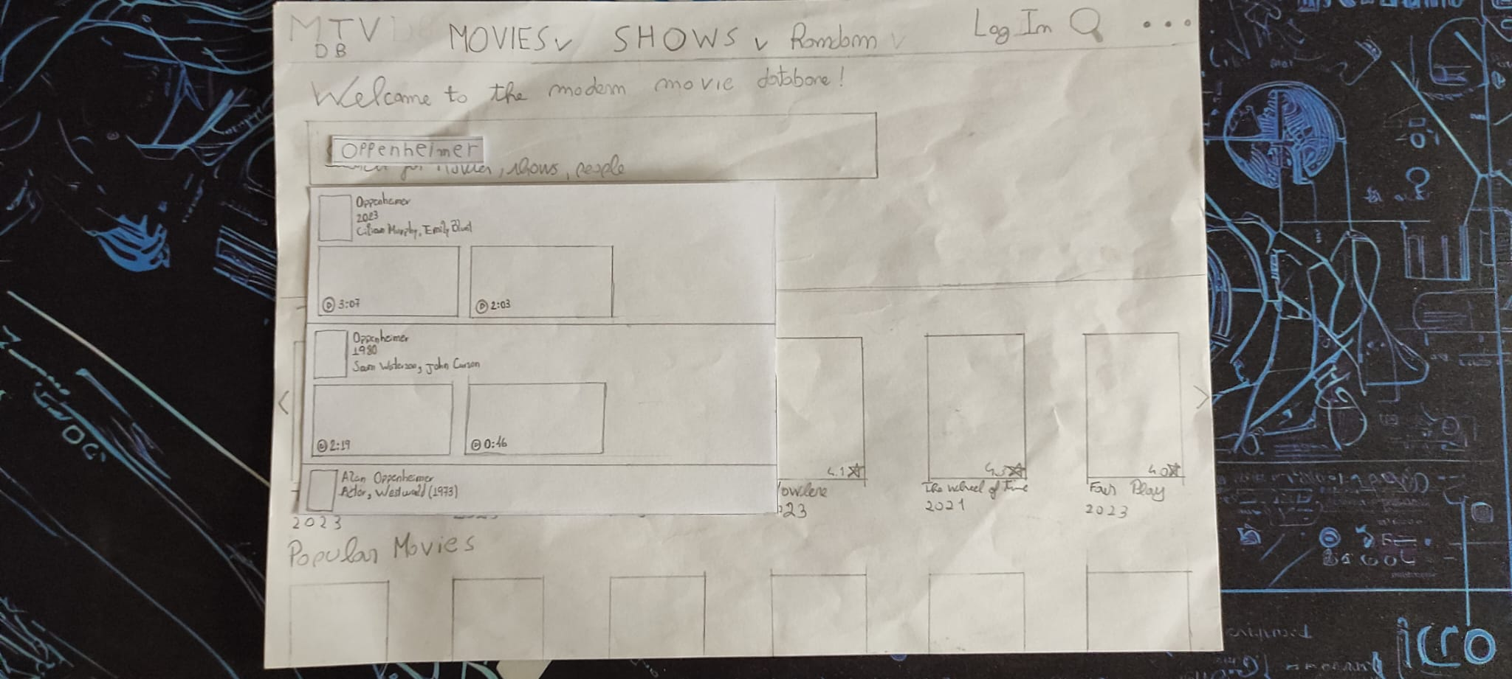

* He types the name of the movie in the search bar and is

presented with options to choose from.

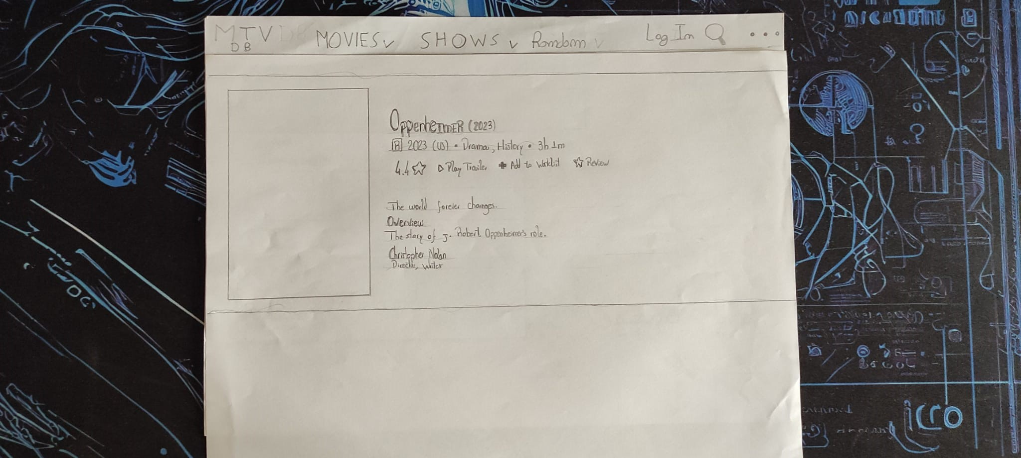

* He chooses the recently released movie, and gets to the movie page.

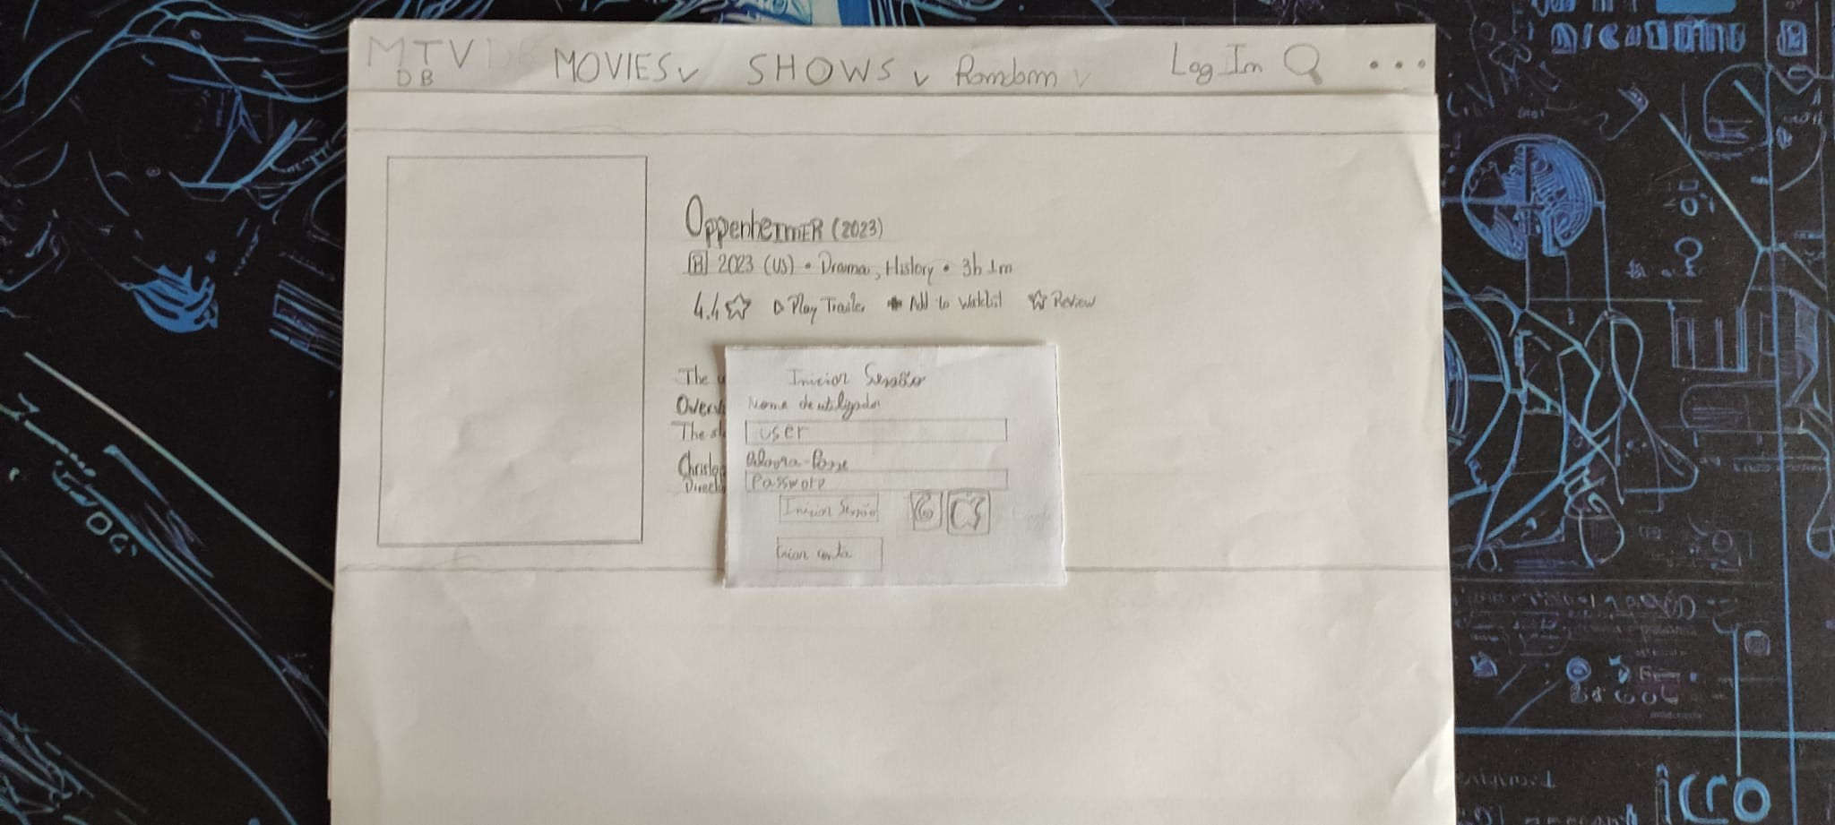

* To add this movie to the watchlist, the user needs to login on

the website, and a popup apears to do so.

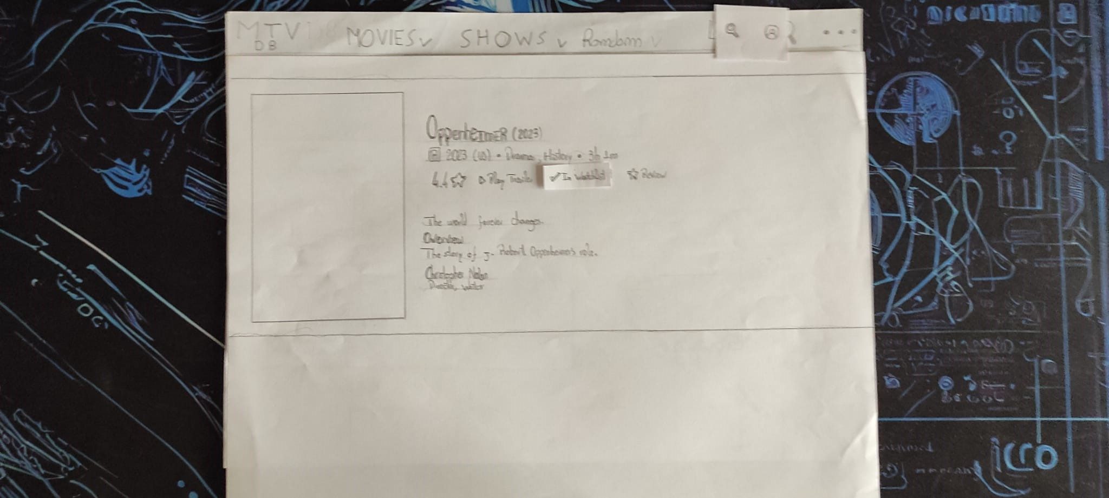

* After proceeding with the login, the movie gets added to the watchlist, and the interface changes to show it.

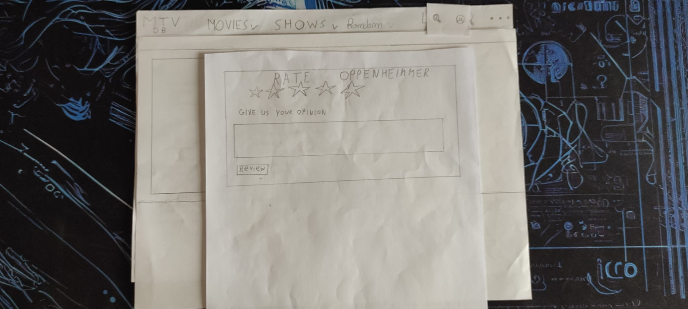

* For reviewing the movie, a new page pops up so that the user

can review it properly.

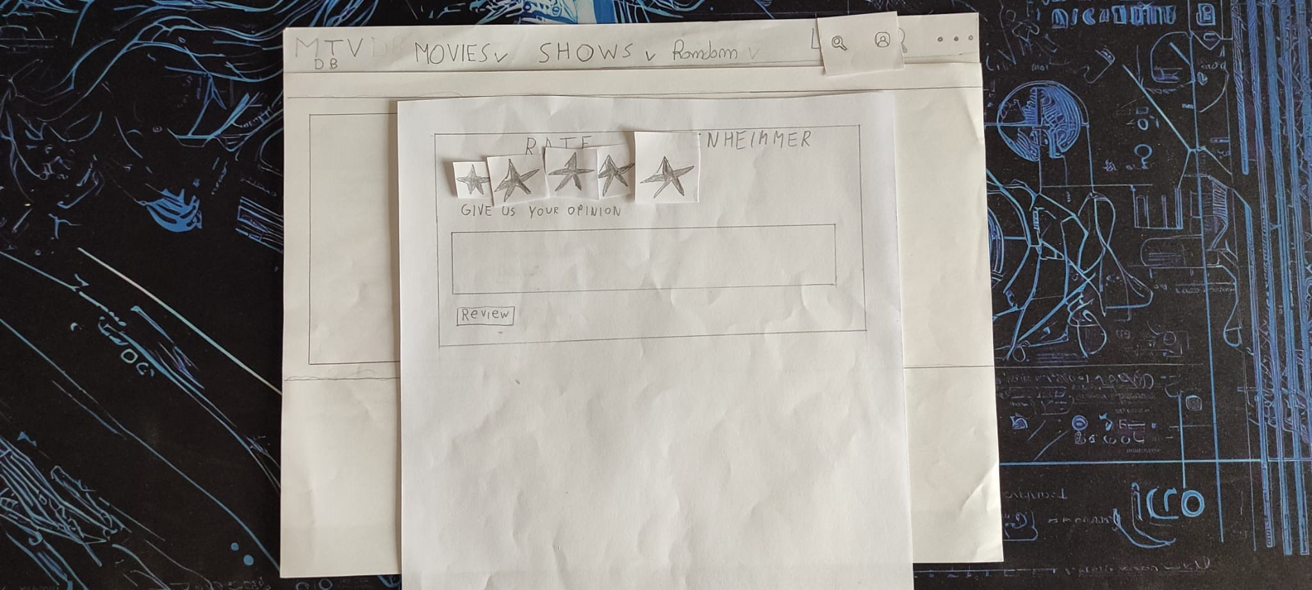

* The user reviews the movie with five stars.

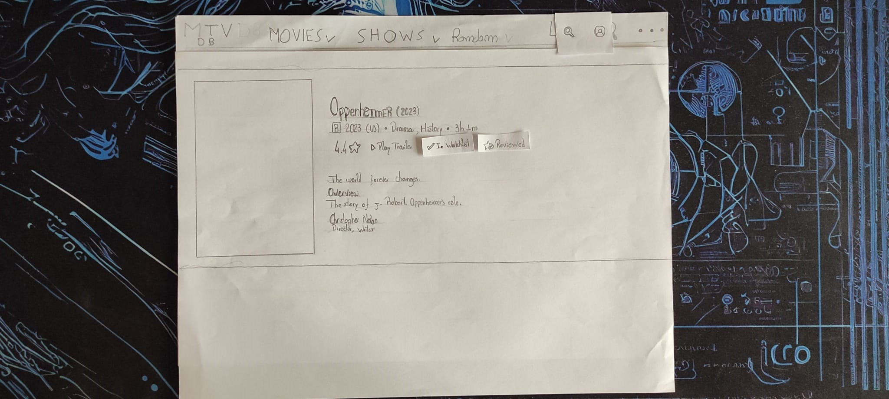

* The interface changes, now showing that the movie is both reviewed and added to the watchlist

## Scenario 3



* The user pretends to find the most popular comedy movie form 2014.

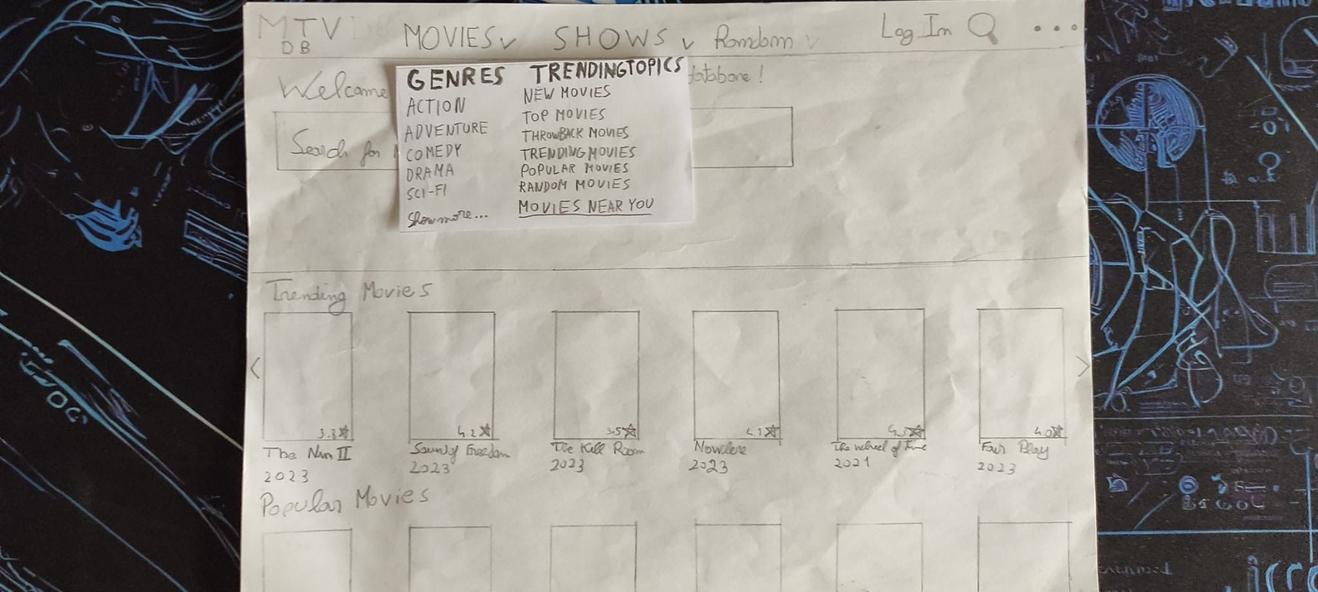

* The user decides to go to the movie dropdown, and selects popular movies.

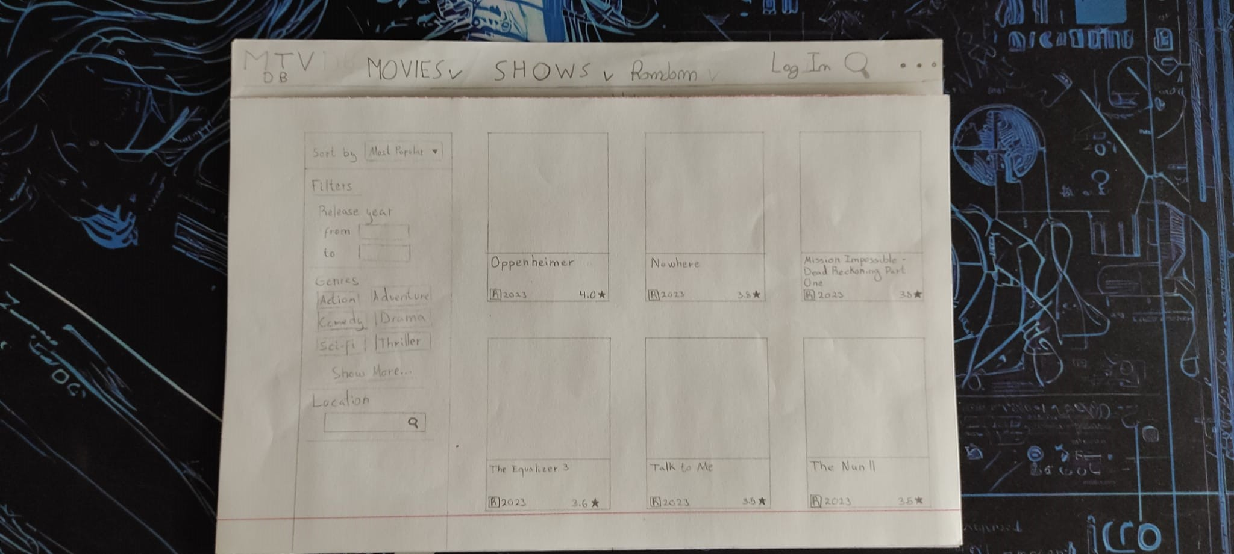

* The user is presented with a page listing the movies, as well with a lot of filters to aplly.

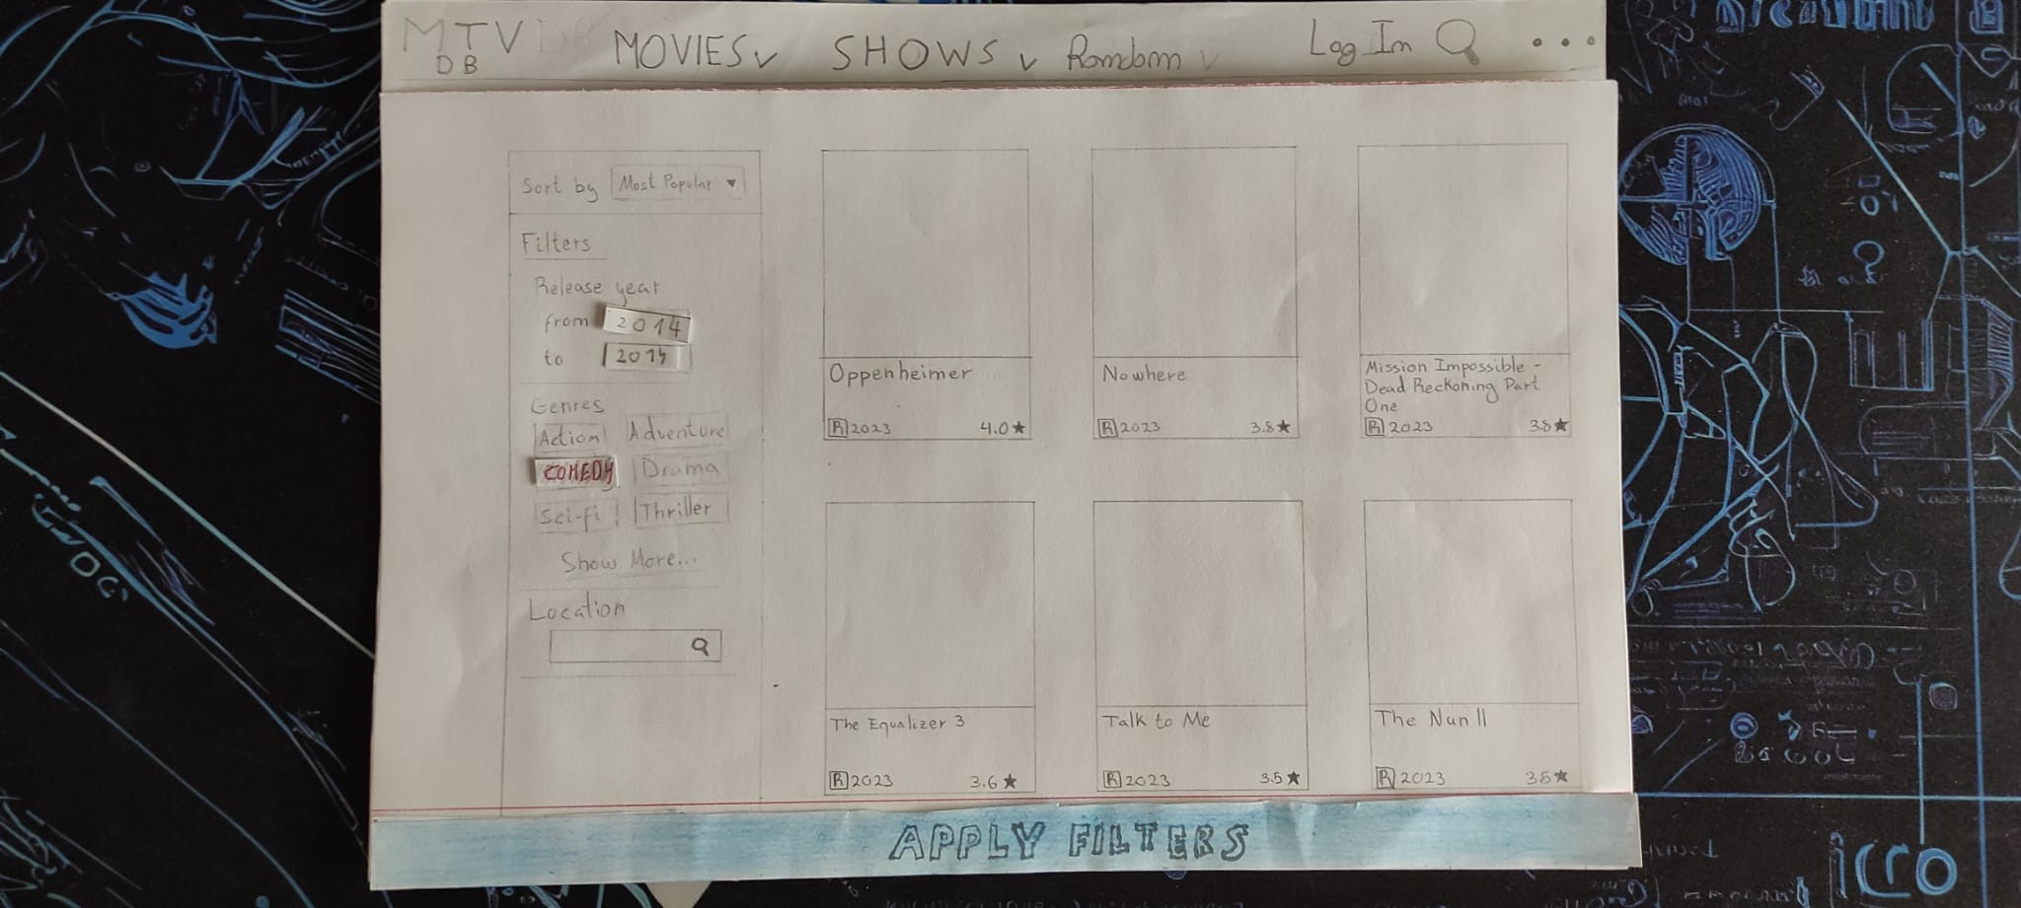

* The user selects the comedy filter, and inserts a range of movies from 2014.

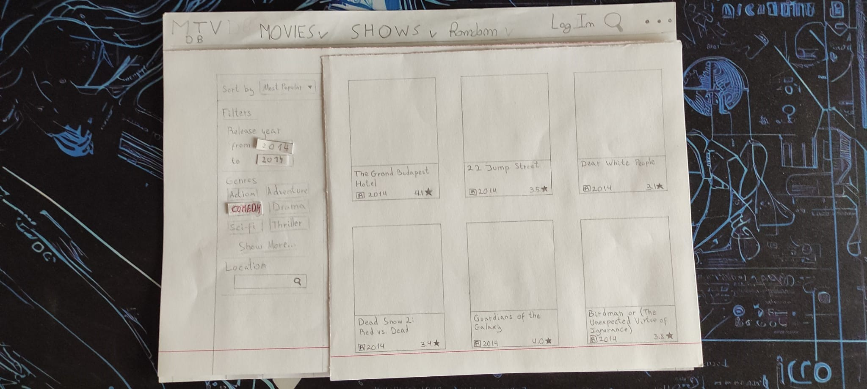

* After clicking the “Aplly Filters” button, he is presented with a listing of the most popular movies of comedy from 2014.

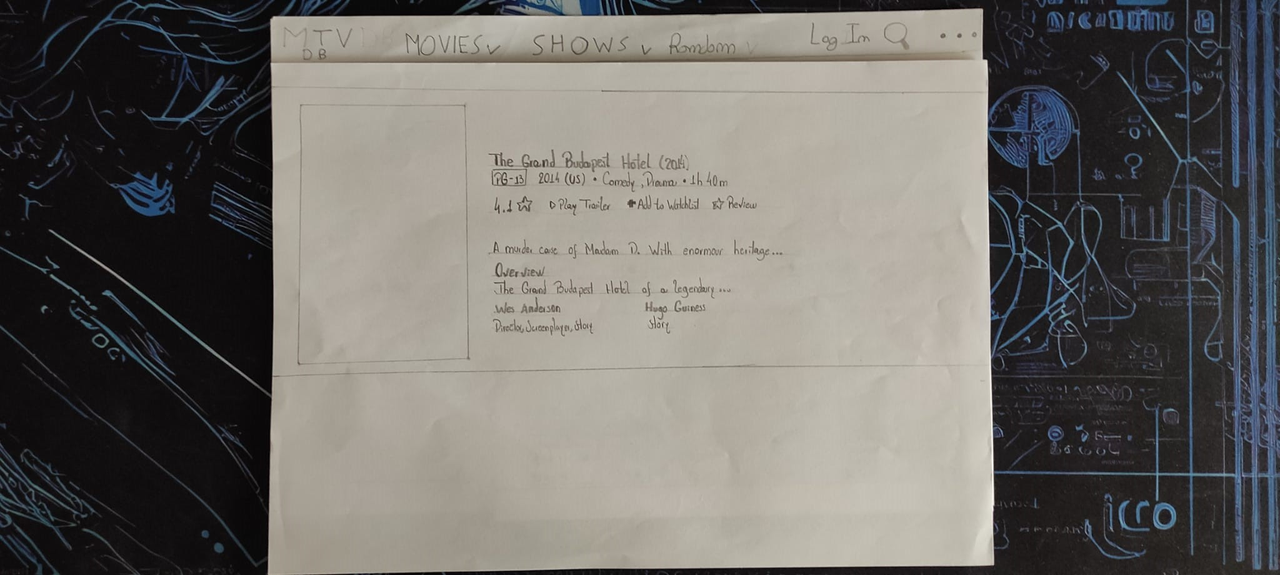

* Then, he clicks on the first movie on the list and is presented with the page of The Grand Budapest Hotel.

## Scenario 4



* The user pretends to lookup for movies that were filmed near his location.



* He goes to the “Movies” dropdown and clicks on the “Movies Near You” option

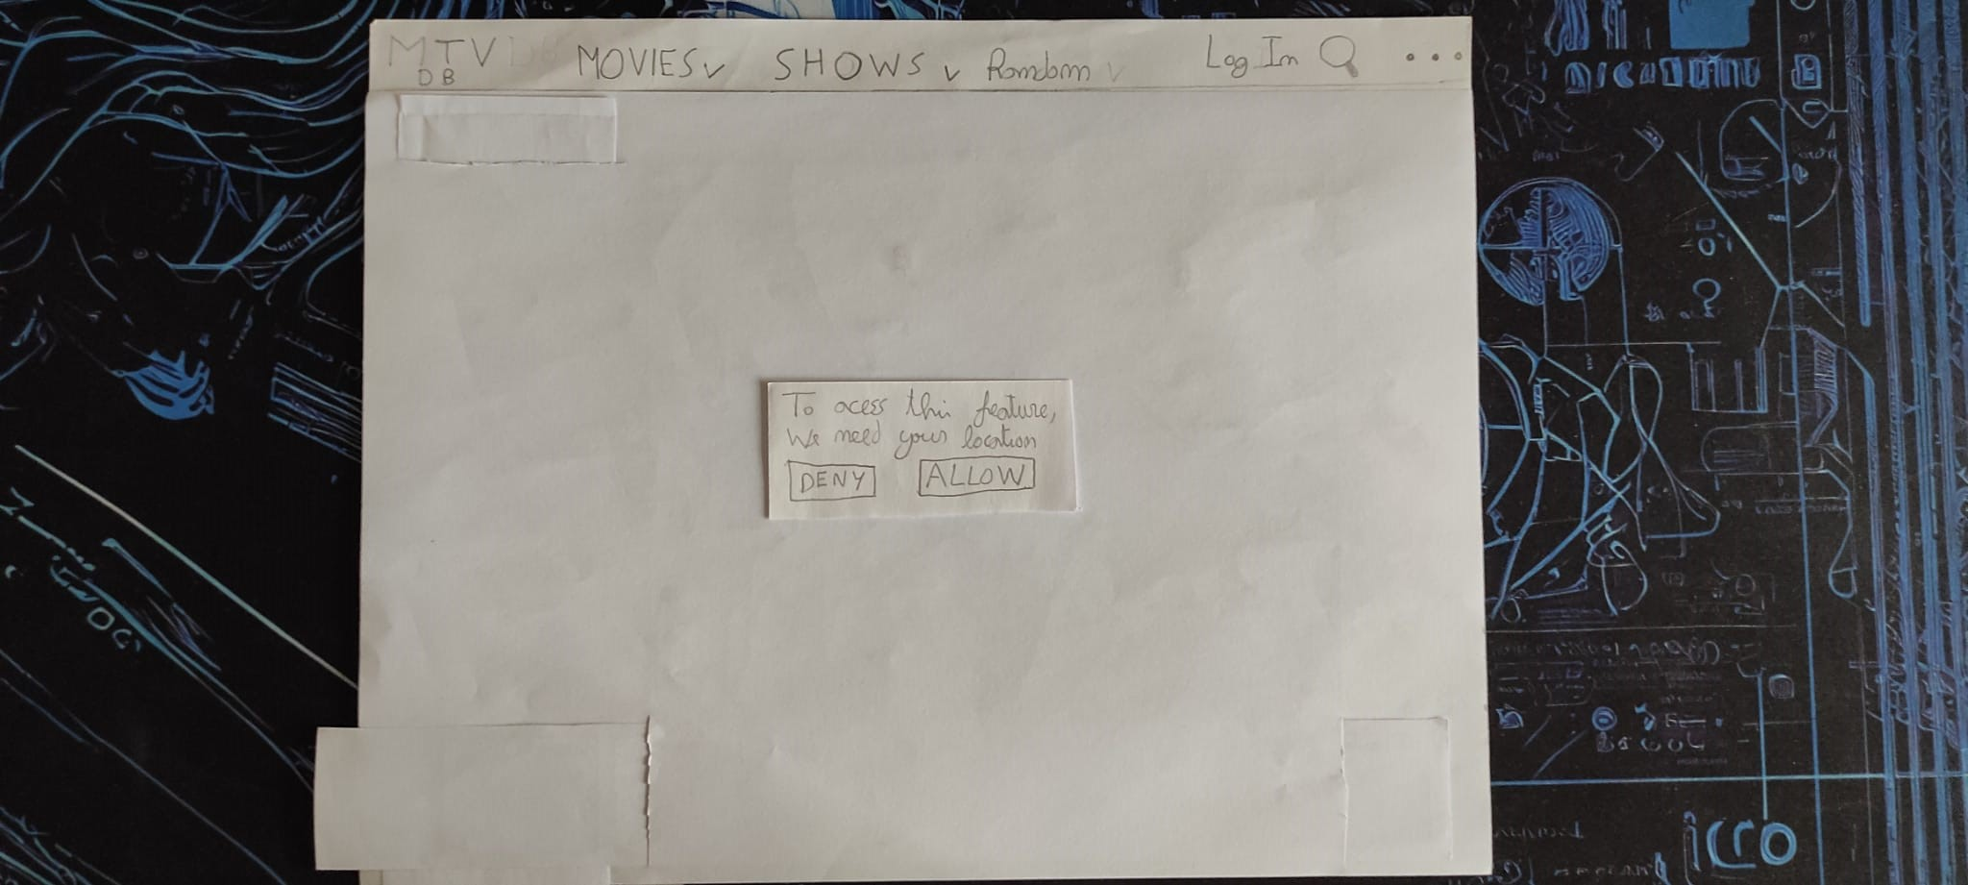

* The website asks the user for permission to access his current location.

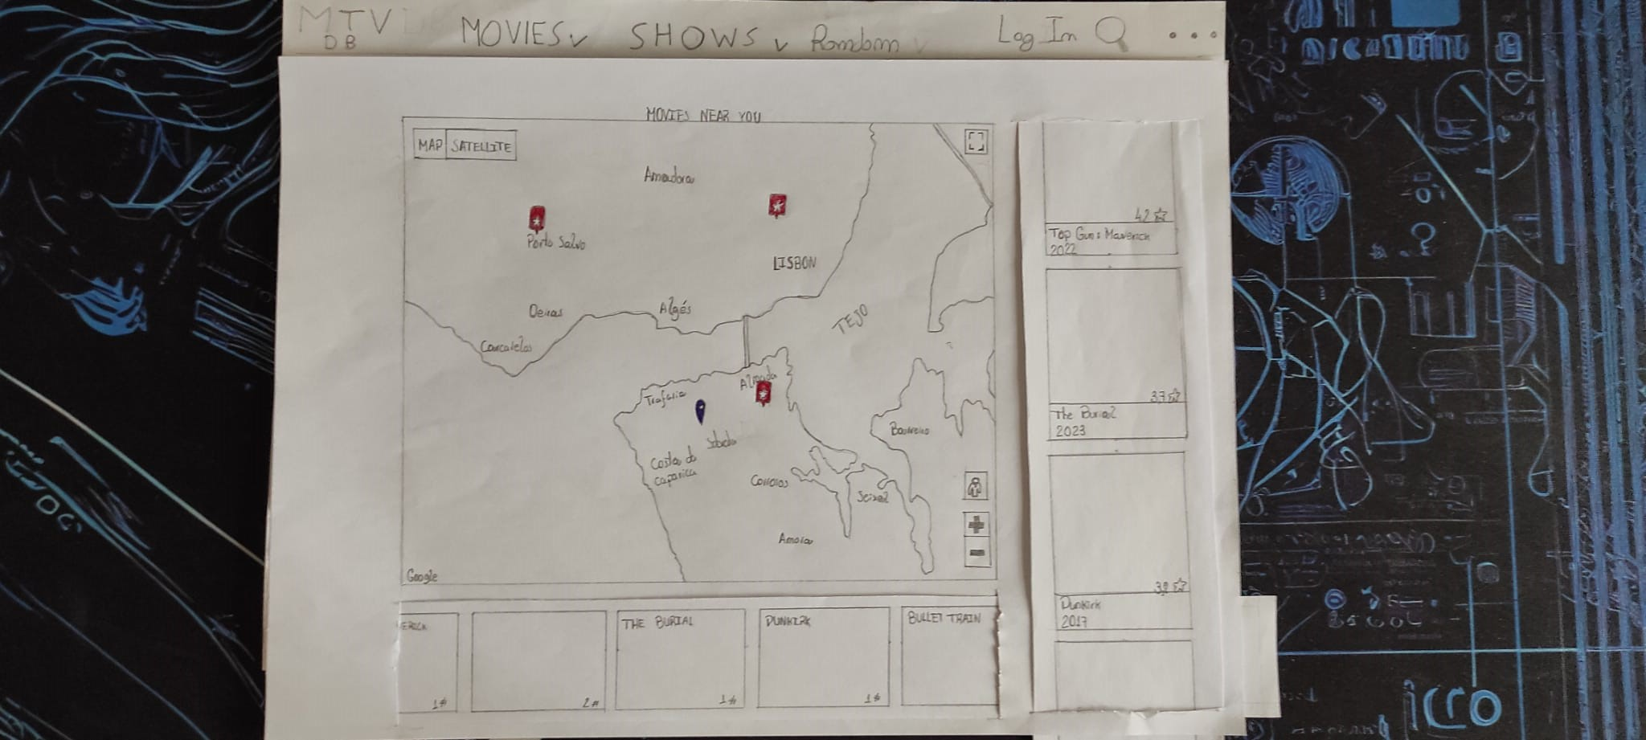

* The user is presented with a map showing his location with pinpoints on locations where movies were recorded and the corresponding movies and images on the right and below, respectively.

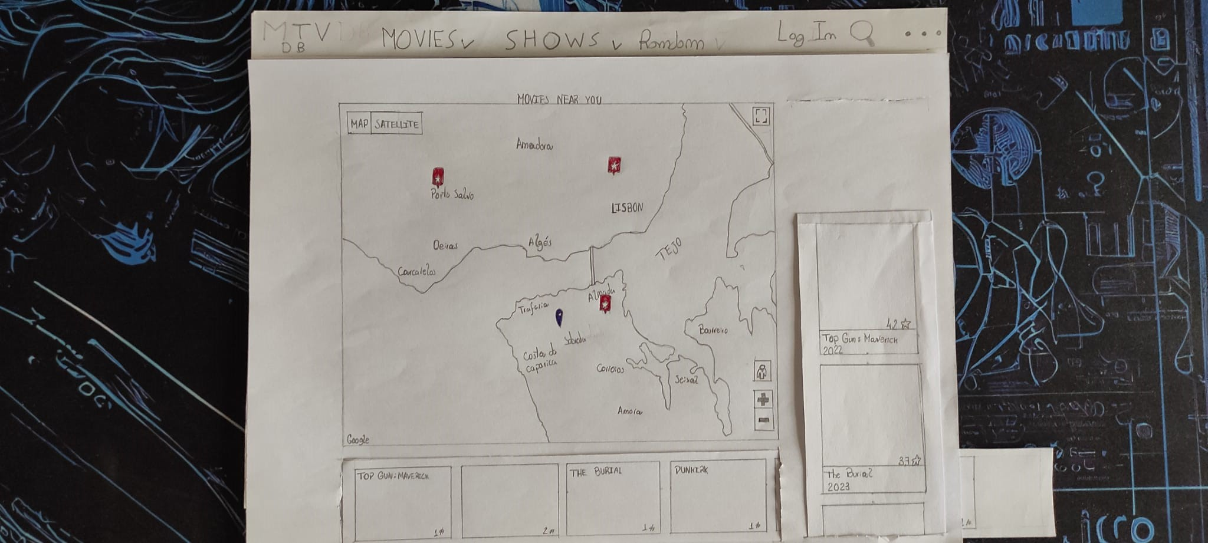

* When the user selects a pinpoint, the corresponding movie and images are centered on the right and below, showing what movie and places the pinpoint is about.

# Briefing

MTVDB is a website where users can rate movies and TV shows and also see which TV shows and movies have the best ratings.

Our group realized that the most well-known website with these features, IMDB, is very confusing and not very intuitive. For example, it's not easy to perform a simple search like looking for comedy movies.

In summary, it's a site similar to IMDB but more intuitive and with an additional unique feature, which is to see which movies and TV series were filmed near the user.

# Scenarios

## Scenario 1

Imagine you want to find a film by the writer Cristopher Nolan, but you don’t remember its title. (Hint: it rhymes with perfection)

## Scenario 2

Imagine you have just watched the movie Oppenheimer and you want to add the movie to your watchlist and make a review on it.

Scenario 3

Imagine you want to find the most popular comedy movie released in 2014.

Scenario 4

Imagine you want to find the movie that was filmed nearest to you.

# Observations

In our testing day, there were 3 users that experimented with our prototype, giving us some opinions/observations:

User 1:

* The User didn’t think the sort types were properly distinguished, more specifically the difference between Most Popular and Top Movies. A possible solution brought up by him was to add a Most Viewed Movies to the sorting list instead of the Most Popular Movies.
* Despite being a feature of our website, we did not make a paper prototype for searching a movie by year in the search bar because we didn’t consider it as a way to complete scenario 3, but the user did.
* The User concluded that the Movies near you feature is not intuitive to find, needing something to highlight it.
* The User thought that adding icons to the Trending topics and genres categories in the Movies dropdown would make it more intuitive to find what you want.
* The User gave a more intuitive way to show movies near you (select the movie you want, and it expands in the side of the screen, showing the title, year and some photos, being also able to redirect to the movie page).

User 2:

* The User wanted to interact with the 3 points in the navigation bar, but as they are not needed to complete any of the scenarios, we didn’t find them relevant to make in the paper prototype.
* User suggested a list of all reviews made by the account on multiple films.

User 3:

* The user tried to write his location in the search bar as a way to search for movies near him, possibly being an interesting feature (while being considerate of location safety).
* When the user saw the “Movies near you” topics, he thought it meant movies in theaters near him, hinting at a possible renaming of the feature.